Solid of Revolution

Definition
# Source: AI Source: Provided by: [Data Path: Persons Table -> ID Column: 1, Name_En Column: Motasem Essam] -> From: [ChatGPT] on [7/25/2026]
A Solid of Revolution is a three-dimensional solid generated by rotating a two-dimensional plane region through a complete revolution of ${360}^{∘}$ around a fixed straight line in the same plane, called the Axis of Revolution.
As the plane region rotates around the axis, it sweeps through space and forms a three-dimensional volume bounded by a surface of revolution.
The generated solid has circular cross-sections perpendicular to its axis of revolution, although their radii may vary along the axis.

Geometric Representation
# Source: AI Source: Provided by: [Data Path: Persons Table -> ID Column: 1, Name_En Column: Motasem Essam] -> From: [ChatGPT] on [7/25/2026]
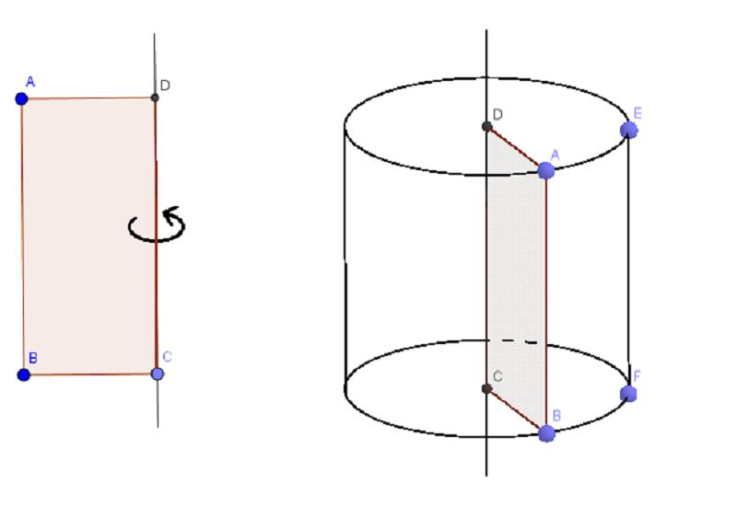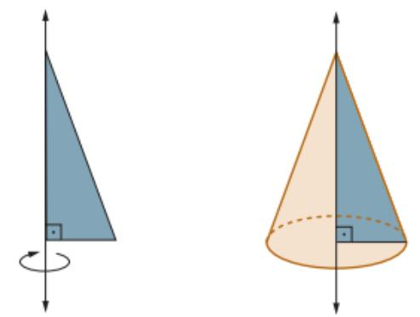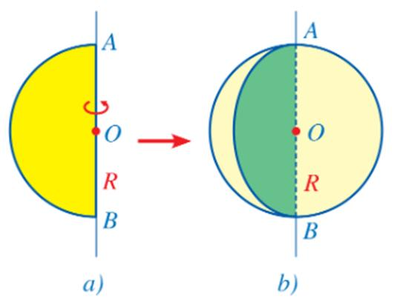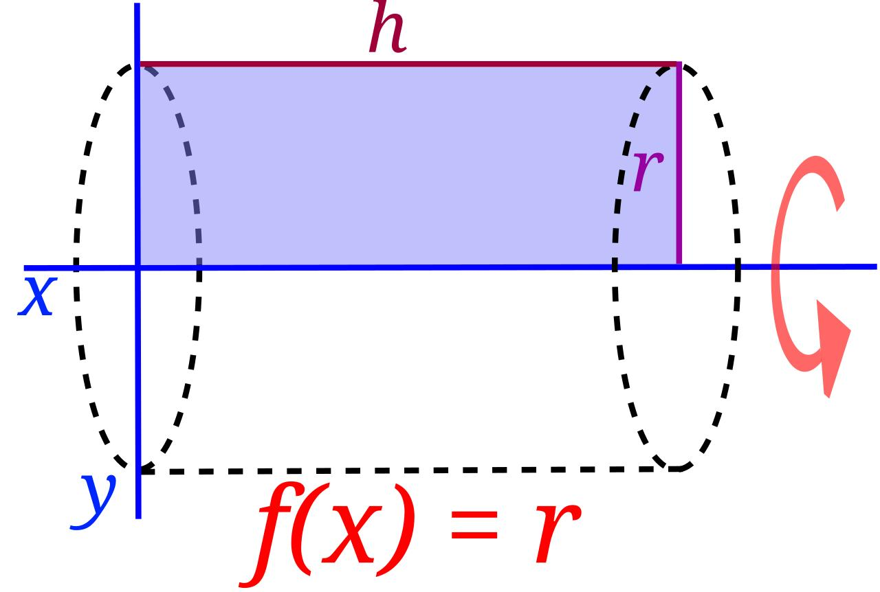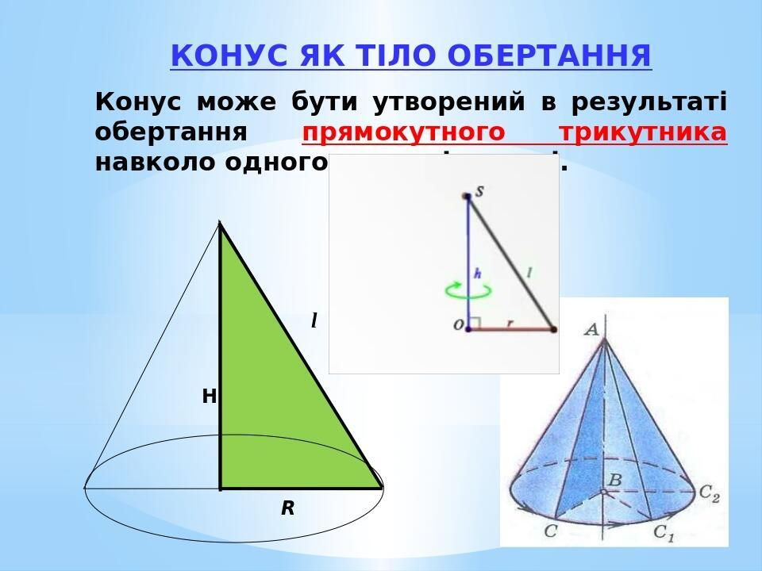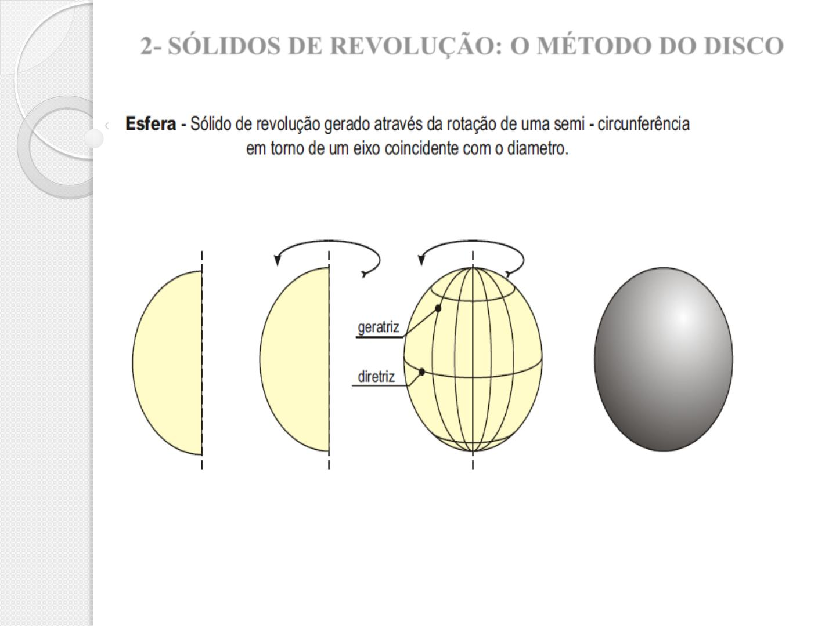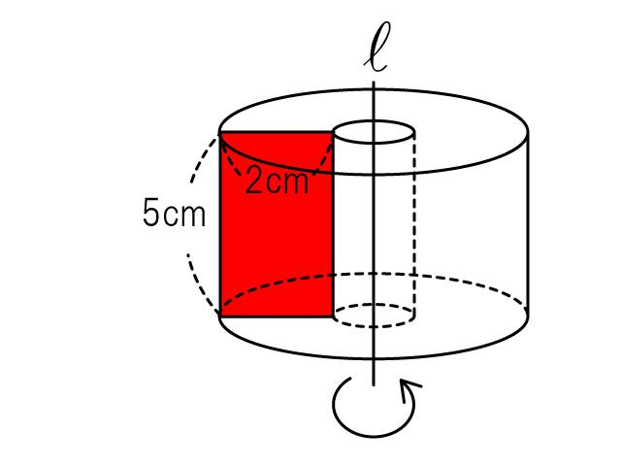
A solid of revolution can be generated by rotating different plane regions, including:
- Rectangular regions.
- Triangular regions.
- Circular and semicircular regions.
- Elliptical regions.
- Parabolic regions.
- Hyperbolic regions.
- Irregular regions.
The resulting solid depends on the shape of the generating region and the position of the rotation axis.

Geometric Structure
# Source: AI Source: Provided by: [Data Path: Persons Table -> ID Column: 1, Name_En Column: Motasem Essam] -> From: [ChatGPT] on [7/25/2026]
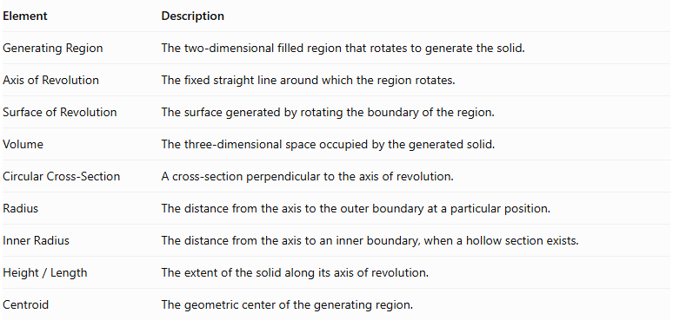
Element | Description
Generating Region | The two-dimensional filled region that rotates to generate the solid.
Axis of Revolution | The fixed straight line around which the region rotates.
Surface of Revolution | The surface generated by rotating the boundary of the region.
Volume | The three-dimensional space occupied by the generated solid.
Circular Cross-Section | A cross-section perpendicular to the axis of revolution.
Radius | The distance from the axis to the outer boundary at a particular position.
Inner Radius | The distance from the axis to an inner boundary, when a hollow section exists.
$$Height/Length$$ | The extent of the solid along its axis of revolution.
Centroid | The geometric center of the generating region.

Fundamental Characteristics
# Source: AI Source: Provided by: [Data Path: Persons Table -> ID Column: 1, Name_En Column: Motasem Essam] -> From: [ChatGPT] on [7/25/2026]
- Rotational Symmetry: The solid remains unchanged under rotation around its axis.
- Circular Cross-Sections: Cross-sections perpendicular to the axis are circular disks or annuli.
- Variable Radius: The radius can change along the axis, producing different profiles.
- Continuous Surface: Its curved boundary is generally a surface of revolution.
- Axis of Revolution: The axis defines the position and orientation of the generated solid.
- Three-Dimensional Volume: Rotating a filled region generates a solid, rather than merely a surface.

Types of Solids of Revolution

According to Geometric Shape

A. Cylindrical Solids of Revolution
# Source: AI Source: Provided by: [Data Path: Persons Table -> ID Column: 1, Name_En Column: Motasem Essam] -> From: [ChatGPT] on [7/25/2026]
Generated by rotating a rectangular region around one of its sides or an appropriate parallel axis.
Examples: right circular cylinder and hollow cylindrical solid.
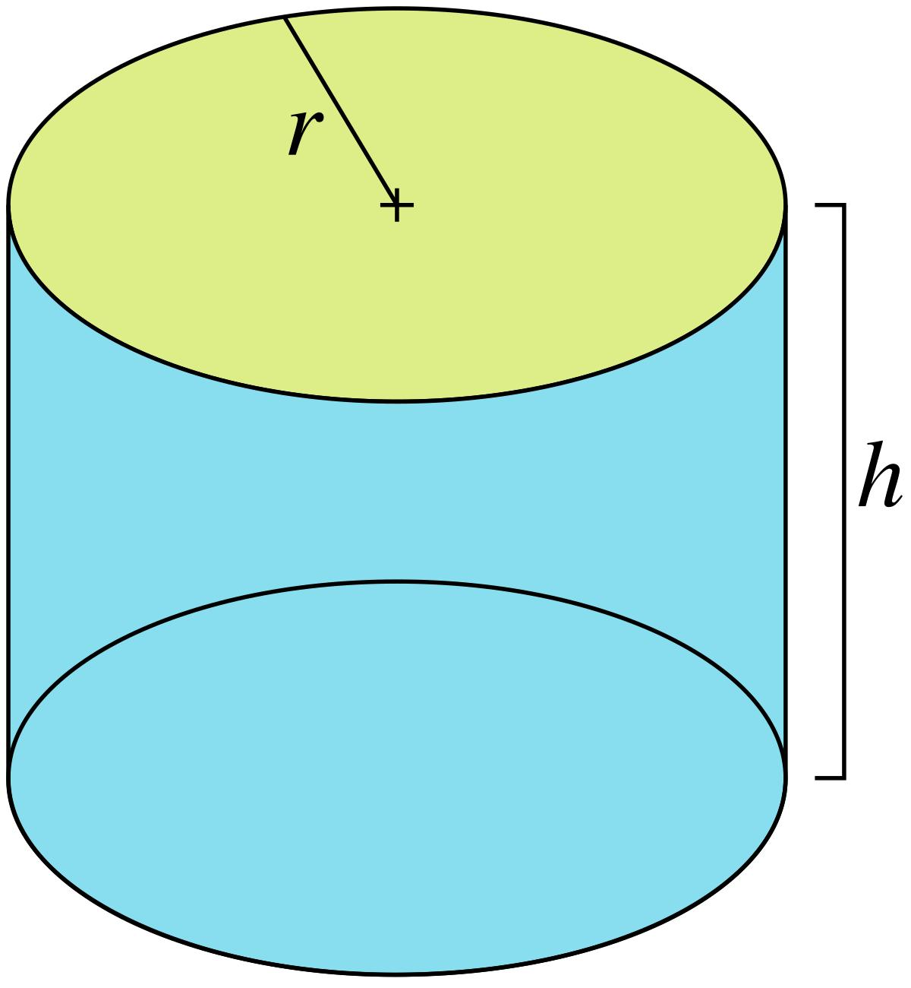

B. Conical Solids of Revolution
# Source: AI Source: Provided by: [Data Path: Persons Table -> ID Column: 1, Name_En Column: Motasem Essam] -> From: [ChatGPT] on [7/25/2026]
Generated by rotating a triangular region around one of its sides, under suitable geometric conditions.
Examples: right circular cone and conical frustum.
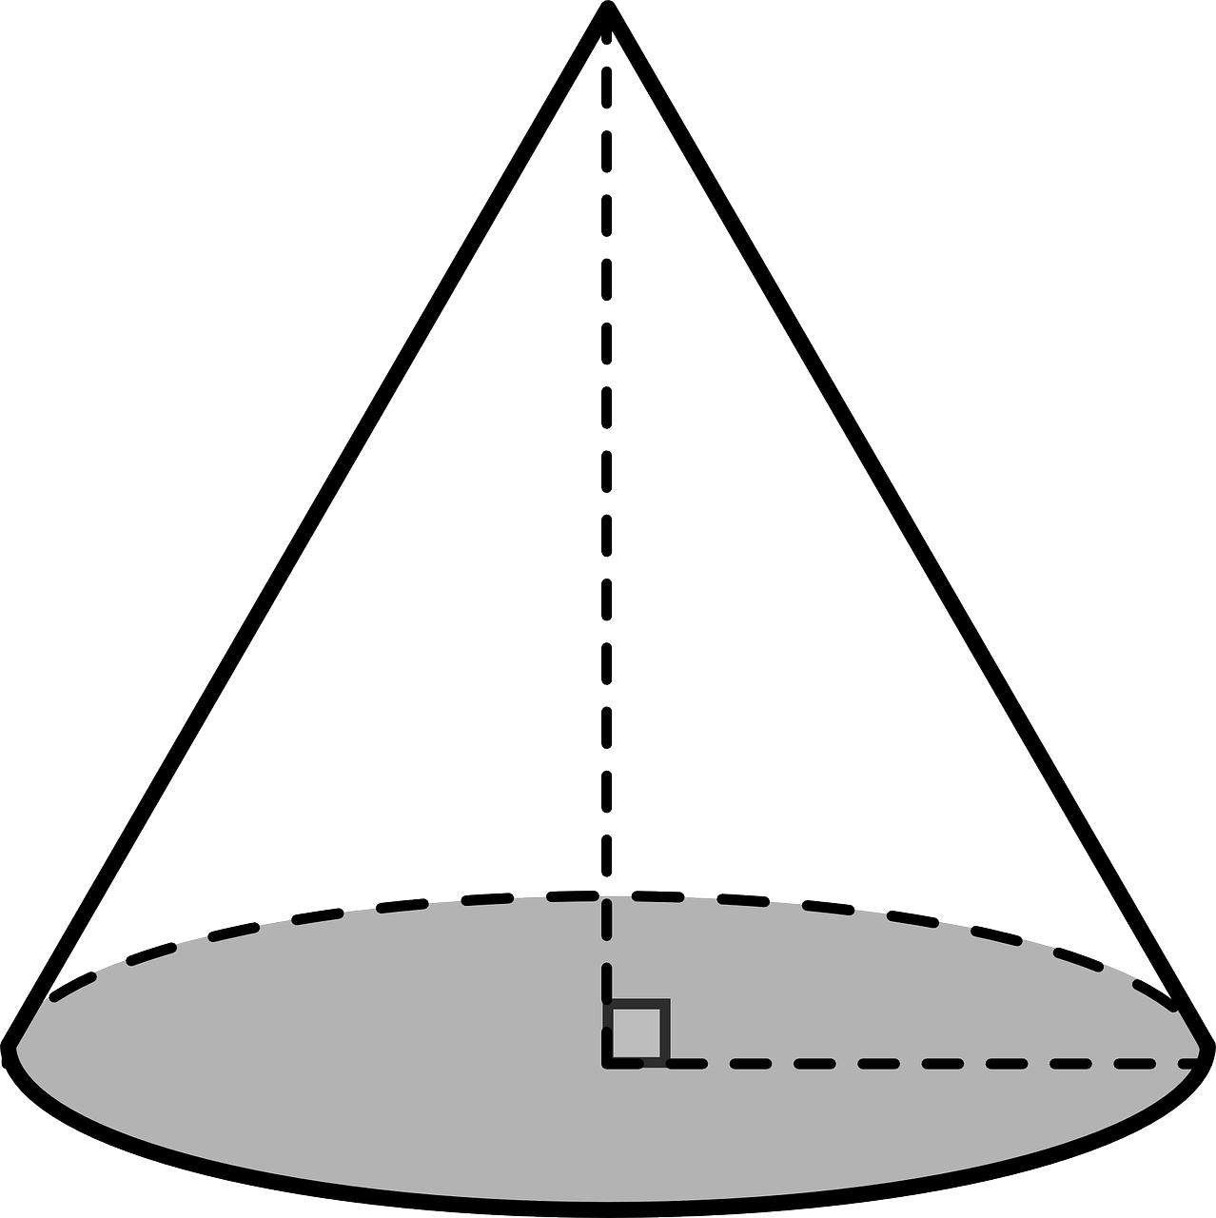

C. Spherical Solids of Revolution
# Source: AI Source: Provided by: [Data Path: Persons Table -> ID Column: 1, Name_En Column: Motasem Essam] -> From: [ChatGPT] on [7/25/2026]
Generated by rotating a semicircular region around its diameter.
Example: sphere.
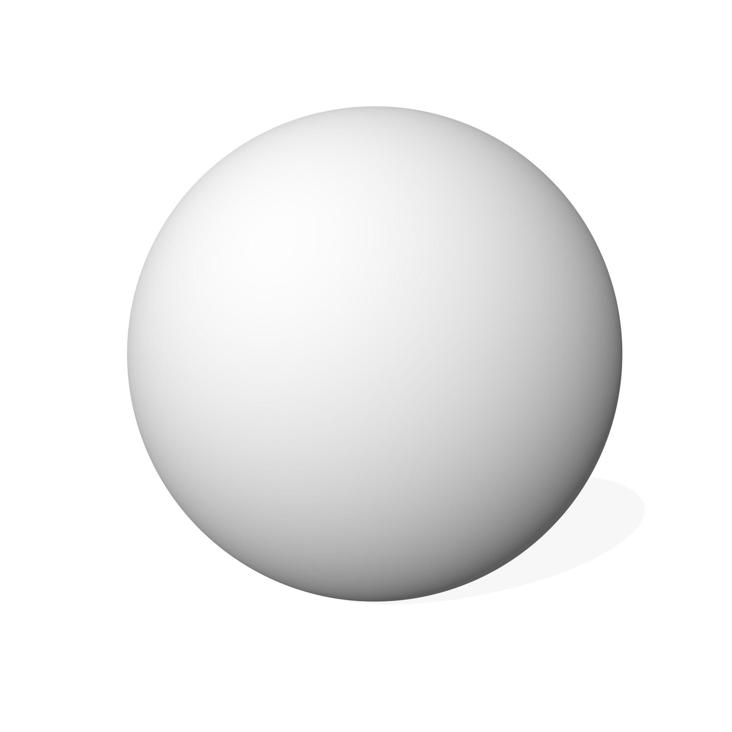

D. Ellipsoidal Solids of Revolution
# Source: AI Source: Provided by: [Data Path: Persons Table -> ID Column: 1, Name_En Column: Motasem Essam] -> From: [ChatGPT] on [7/25/2026]
Generated by rotating an elliptical region around one of its principal axes.
Examples: prolate spheroid and oblate spheroid.
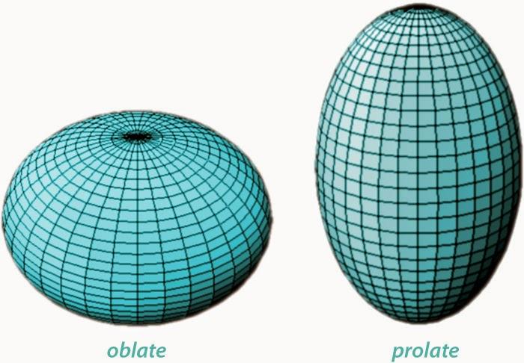

E. Paraboloidal Solids of Revolution
# Source: AI Source: Provided by: [Data Path: Persons Table -> ID Column: 1, Name_En Column: Motasem Essam] -> From: [ChatGPT] on [7/25/2026]
Generated by rotating a suitable parabolic region around its axis of symmetry.
Example: solid elliptic paraboloid.
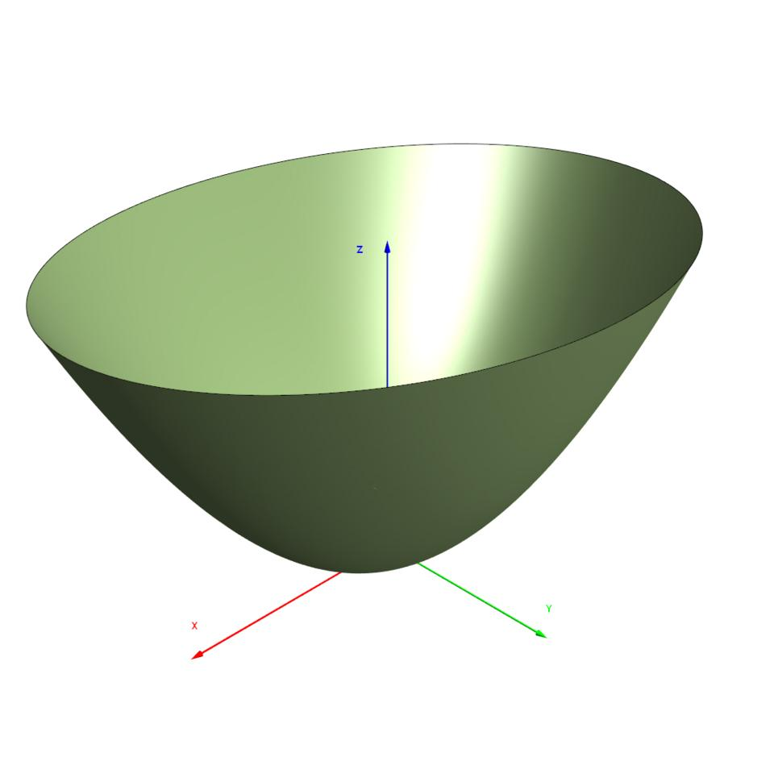

F. Hyperboloidal Solids of Revolution
# Source: AI Source: Provided by: [Data Path: Persons Table -> ID Column: 1, Name_En Column: Motasem Essam] -> From: [ChatGPT] on [7/25/2026]
Generated by rotating suitable hyperbolic regions or curves around particular axes.
Examples: one-sheeted and two-sheeted hyperboloids.
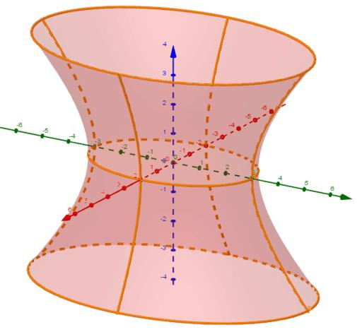

G. Toroidal Solids of Revolution
# Source: AI Source: Provided by: [Data Path: Persons Table -> ID Column: 1, Name_En Column: Motasem Essam] -> From: [ChatGPT] on [7/25/2026]
Generated by rotating a circular region around an external coplanar axis.
Examples: ring torus, horn torus, and spindle torus.
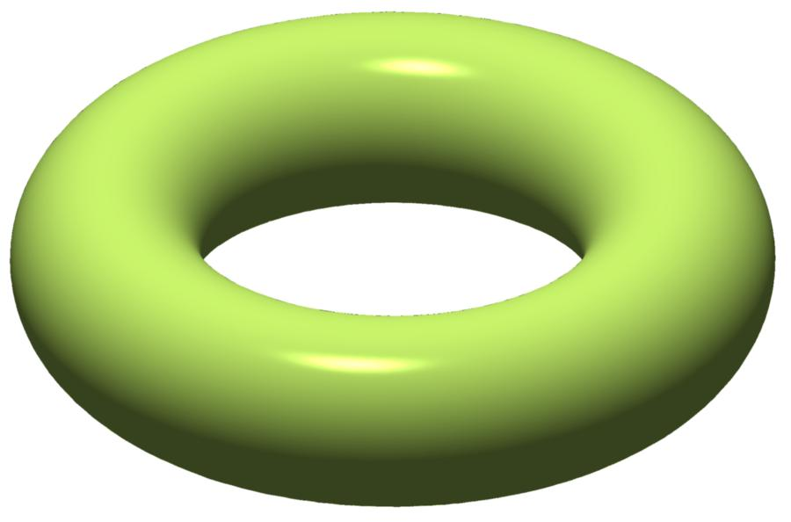
Note: These are common examples, not an exhaustive classification. Other generating regions can produce irregular and composite solids of revolution.

According to the Position of the Axis of Revolution

A. Rotation Around a Boundary Line
# Source: AI Source: Provided by: [Data Path: Persons Table -> ID Column: 1, Name_En Column: Motasem Essam] -> From: [ChatGPT] on [7/25/2026]
The axis coincides with one side or a portion of the boundary of the generating region.
Examples:
- Rectangle rotated around one side → right circular cylinder.
- Right triangle rotated around one perpendicular leg → right circular cone.
- Semicircle rotated around its diameter → sphere.

B. Rotation Around an External Axis
# Source: AI Source: Provided by: [Data Path: Persons Table -> ID Column: 1, Name_En Column: Motasem Essam] -> From: [ChatGPT] on [7/25/2026]
The axis lies outside the generating region and does not intersect its interior.
Examples:
- Circular disk rotated around an external coplanar axis → toroidal solid.
- Rectangular region rotated around an external parallel axis → hollow cylindrical solid.

C. Rotation Around an Internal Axis
# Source: AI Source: Provided by: [Data Path: Persons Table -> ID Column: 1, Name_En Column: Motasem Essam] -> From: [ChatGPT] on [7/25/2026]
The axis passes through the interior of the generating region.
Examples:
- Elliptical region rotated around its major axis → prolate spheroid.
- Elliptical region rotated around its minor axis → oblate spheroid.
- Circular disk rotated around a diameter → sphere.
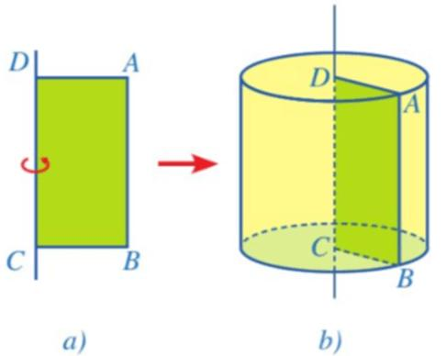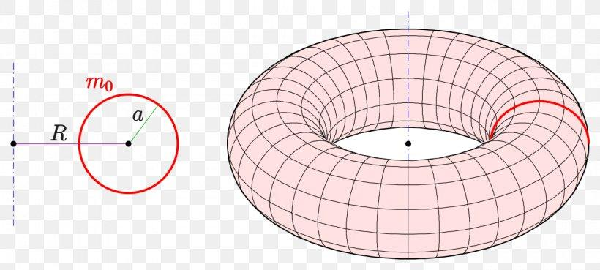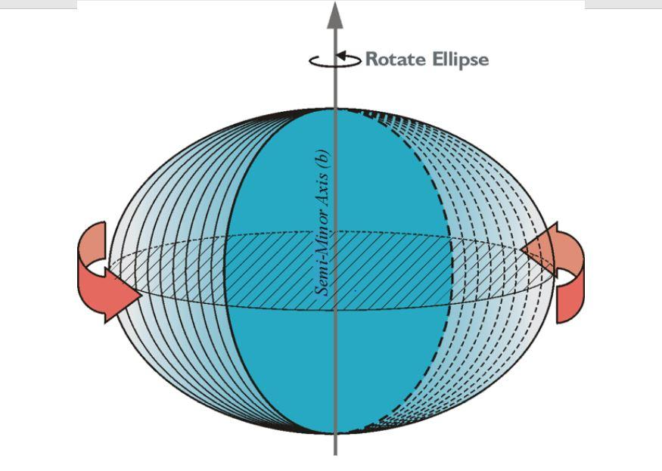

According to the Generating Boundary
# Source: AI Source: Provided by: [Data Path: Persons Table -> ID Column: 1, Name_En Column: Motasem Essam] -> From: [ChatGPT] on [7/25/2026]
- Straight-Line Generated Solids: Generated by rotating straight-line portions of a region's boundary, such as cylindrical and conical surfaces.
- Circular-Arc Generated Solids: Generated by rotating circular arcs, such as spherical surfaces and toroidal surfaces.
- Elliptical-Curve Generated Solids: Generated by rotating elliptical curves, such as spheroidal surfaces.
- Parabolic-Curve Generated Solids: Generated by rotating parabolic curves, such as paraboloidal surfaces.
- Hyperbolic-Curve Generated Solids: Generated by rotating hyperbolic curves, such as hyperboloidal surfaces.
- Irregular-Curve Generated Solids: Generated by rotating non-standard curves, producing irregular surfaces of revolution.

Mathematical Representation
# Source: AI Source: Provided by: [Data Path: Persons Table -> ID Column: 1, Name_En Column: Motasem Essam] -> From: [ChatGPT] on [7/25/2026]
A solid of revolution can be represented mathematically by rotating a plane region around a coordinate axis.

Rotation Around the X-Axis
# Source: AI Source: Provided by: [Data Path: Persons Table -> ID Column: 1, Name_En Column: Motasem Essam] -> From: [ChatGPT] on [7/25/2026]
For a point $(x,y)$ rotated through an angle $θ$ around the X-axis:
$$X=x$$
$$Y=ycosθ$$
$$Z=ysinθ$$
Where:
$$0≤θ≤2π$$
The resulting three-dimensional coordinates describe the points swept out by the generating region.

Rotation Around the Y-Axis
# Source: AI Source: Provided by: [Data Path: Persons Table -> ID Column: 1, Name_En Column: Motasem Essam] -> From: [ChatGPT] on [7/25/2026]
For a point $(x,y)$ rotated around the Y-axis:
$$X=xcosθ$$
$$Y=y$$
$$Z=xsinθ$$
Where:
$$0≤θ≤2π$$

Volume Using the Disk Method
# Source: AI Source: Provided by: [Data Path: Persons Table -> ID Column: 1, Name_En Column: Motasem Essam] -> From: [ChatGPT] on [7/25/2026]
When a region under $y=f(x)$ is rotated around the X-axis:
$$\boxed{V=π\int_{a}^{b}{[f(x)]^{2} dx}}$$
Where:
- $f(x)$ = radius of each circular cross-section.
- $a,b$ = limits along the X-axis.
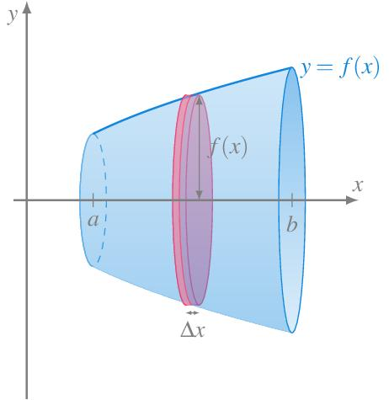

Volume Using the Washer Method
# Source: AI Source: Provided by: [Data Path: Persons Table -> ID Column: 1, Name_En Column: Motasem Essam] -> From: [ChatGPT] on [7/25/2026]
When the generating region lies between two curves, rotation can produce circular cross-sections with holes.
$$\boxed{V=π\int_{a}^{b}{[R(x)^{2}-r(x)^{2}] dx}}$$
Where:
- $R(x)$ = outer radius.
- $r(x)$ = inner radius.
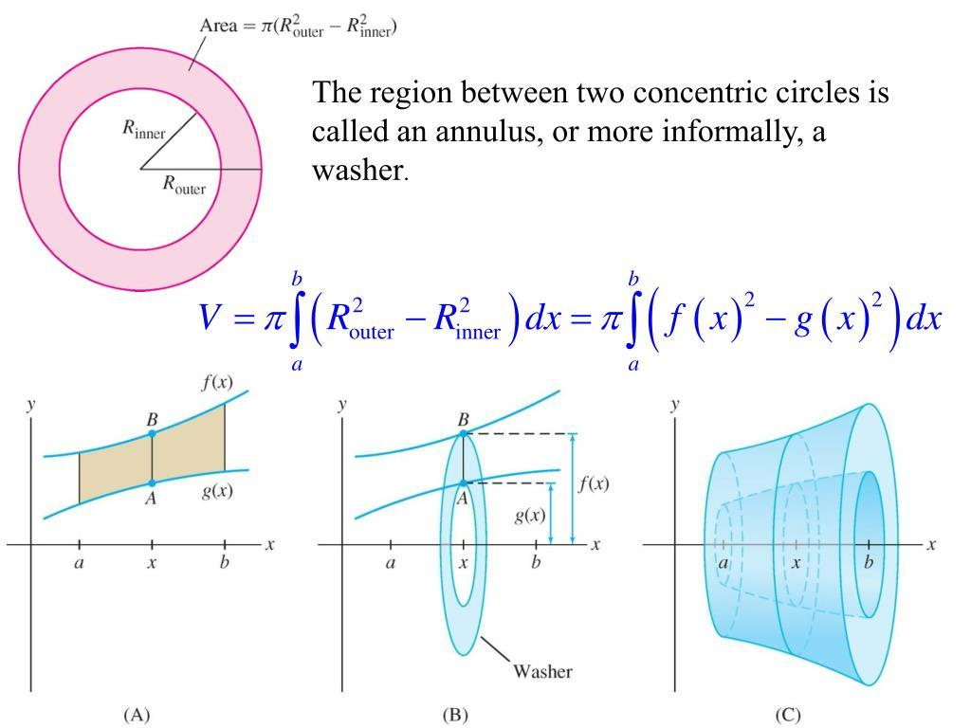

Volume Using the Cylindrical Shell Method
# Source: AI Source: Provided by: [Data Path: Persons Table -> ID Column: 1, Name_En Column: Motasem Essam] -> From: [ChatGPT] on [7/25/2026]
For a region rotated around the Y-axis:
$$\boxed{V=2π\int_{a}^{b}{x[f(x)-g(x)]} dx}$$
Where:
- $x$ = radius of the cylindrical shell.
- $f(x)-g(x)$ = shell height.
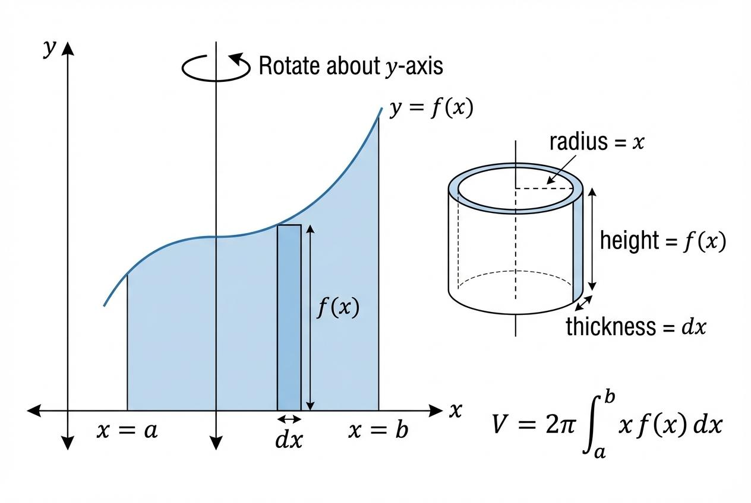

Surface Area of Revolution
# Source: AI Source: Provided by: [Data Path: Persons Table -> ID Column: 1, Name_En Column: Motasem Essam] -> From: [ChatGPT] on [7/25/2026]
For a curve $y=f(x)$ rotated around the X-axis:
$$\boxed{S=2π\int_{a}^{b}{}|f(x)|\sqrt{1+[f'(x)]^{2}} dx}$$
This calculates the area of the curved surface generated by the curve. It does not automatically include flat end faces.

Mathematical Properties of Common Solids of Revolution
# Source: AI Source: Provided by: [Data Path: Persons Table -> ID Column: 1, Name_En Column: Motasem Essam] -> From: [ChatGPT] on [7/25/2026]
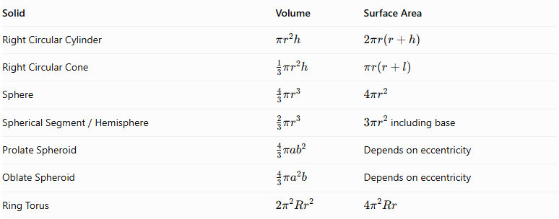
Solid | Volume | Surface Area
Right Circular Cylinder | $$πr^{2}h$$ | $$2πr(r+h)$$
Right Circular Cone | $$\frac{1}{3}πr^{2}h$$ | $$πr(r+l)$$
Sphere | $$\frac{4}{3}πr^{3}$$ | $$4πr^{2}$$
$$SphericalSegment/Hemisphere$$ | $$\frac{2}{3}πr^{3}$$ | $3πr^{2}$ including base
Prolate Spheroid | $$\frac{4}{3}π{ab}^{2}$$ | Depends on eccentricity
Oblate Spheroid | $$\frac{4}{3}πa^{2}b$$ | Depends on eccentricity
Ring Torus | $$2π^{2}{Rr}^{2}$$ | $$4π^{2}Rr$$
Where:
- $r$ = circular radius.
- $h$ = height.
- $l$ = cone slant height.
- $a,b$ = spheroid semi-axes, with $a$ the longer semi-axis for the prolate form and $b$ the shorter semi-axis for the oblate form.
- $R$ = torus major radius.
- $r$ in the torus formulas = tube radius.
Important: The hemisphere surface-area formula includes its flat circular base. Its curved surface area alone is $2πr^{2}$.

Pappus's Centroid Theorem
# Source: AI Source: Provided by: [Data Path: Persons Table -> ID Column: 1, Name_En Column: Motasem Essam] -> From: [ChatGPT] on [7/25/2026]
For a plane region rotated around an external axis in its plane, the volume can be calculated using:
$$\boxed{V=2πdA}$$
Where:
- $A$ = area of the generating region.
- $d$ = distance from the centroid of the region to the axis.
This is useful when the centroid and area are known.

Difference Between a Solid of Revolution and a Surface of Revolution
# Source: AI Source: Provided by: [Data Path: Persons Table -> ID Column: 1, Name_En Column: Motasem Essam] -> From: [ChatGPT] on [7/25/2026]
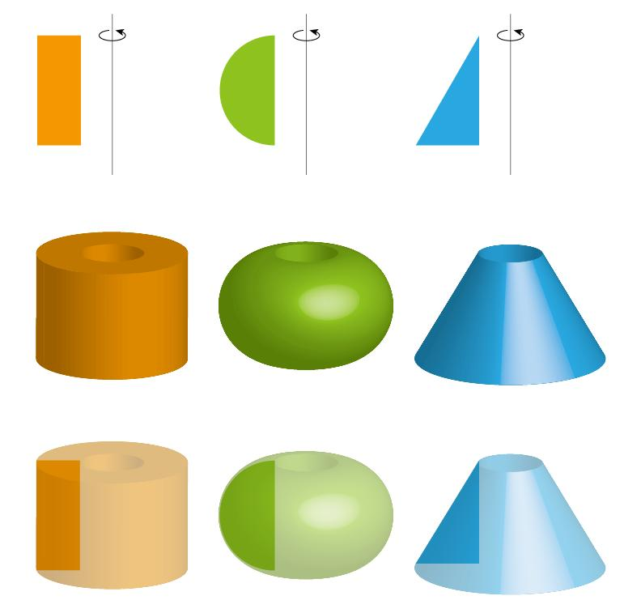
Solid of Revolution
The complete three-dimensional volume generated by rotating a filled plane region.
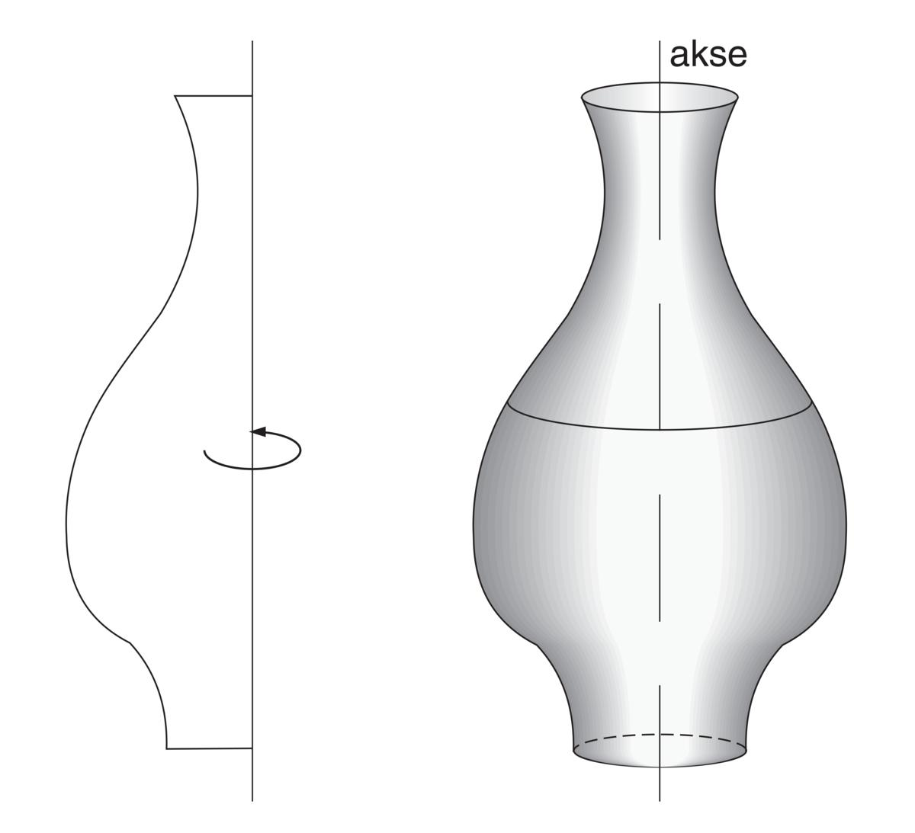
Surface of Revolution
The two-dimensional curved surface generated by rotating a plane curve.
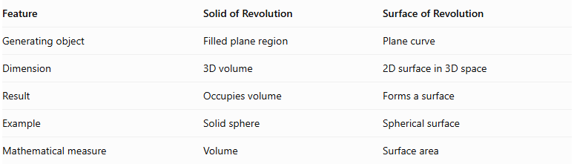
Feature | Solid of Revolution | Surface of Revolution
Generating object | Filled plane region | Plane curve
Dimension | 3D volume | 2D surface in 3D space
Result | Occupies volume | Forms a surface
Example | Solid sphere | Spherical surface
Mathematical measure | Volume | Surface area
A surface of revolution can form the boundary of a solid of revolution, but the two terms do not mean the same thing.

Applications
# Source: AI Source: Provided by: [Data Path: Persons Table -> ID Column: 1, Name_En Column: Motasem Essam] -> From: [ChatGPT] on [7/25/2026]
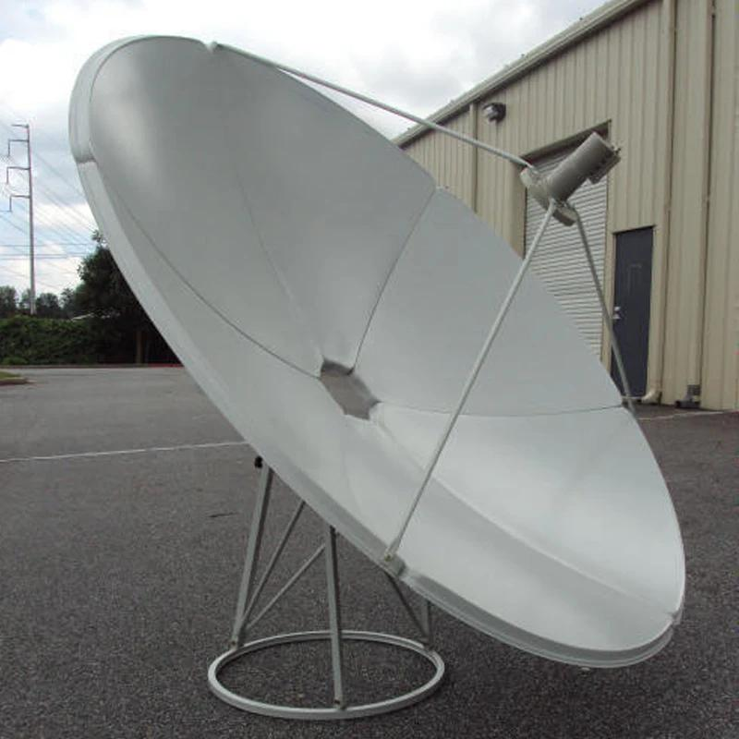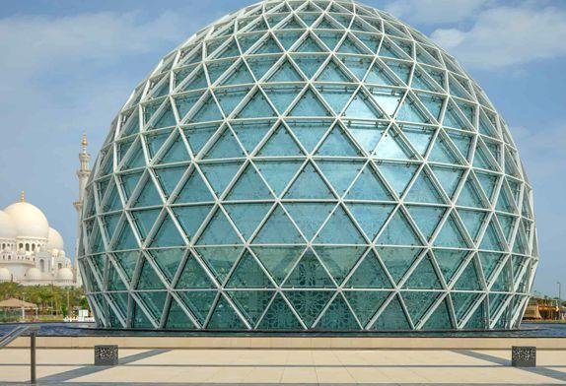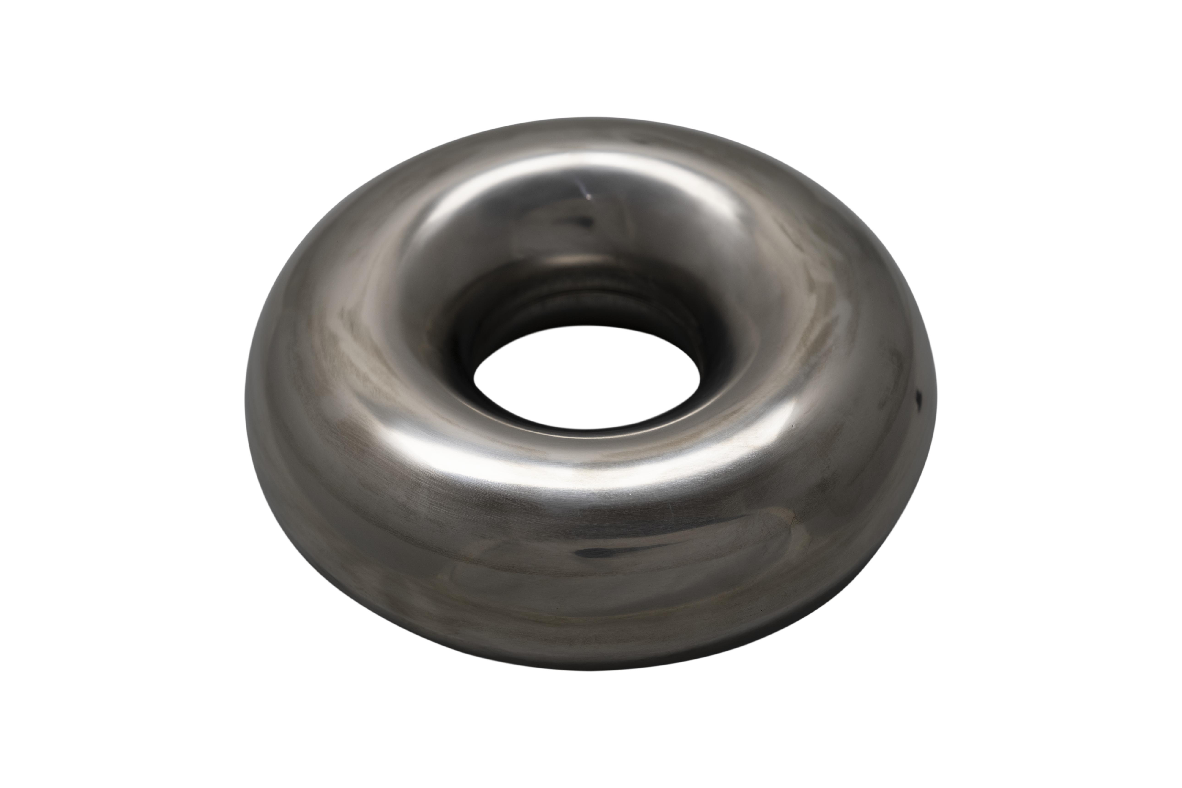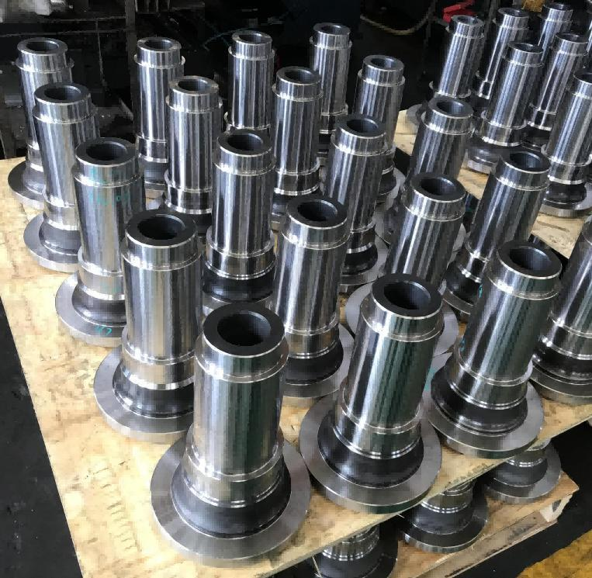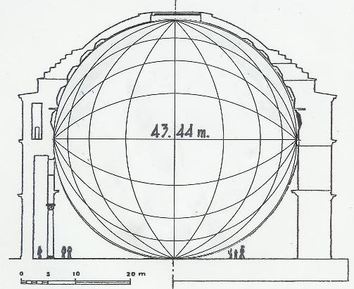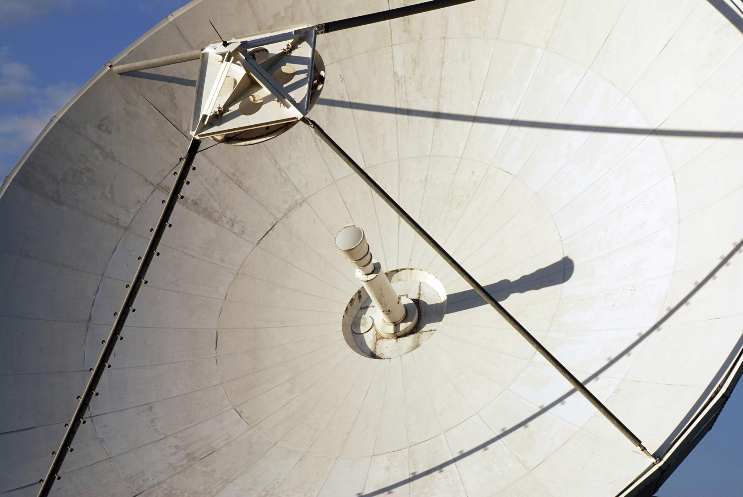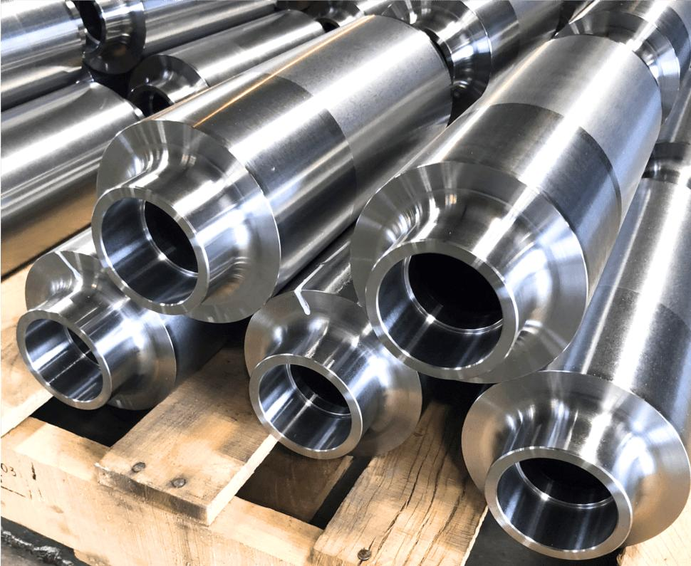
Solids of revolution are widely used in:
- Mechanical Engineering: Shafts, wheels, pulleys, bearings, and turned machine components.
- Manufacturing: Producing cylindrical and conical components using lathes and rotational machining.
- Architecture: Domes, columns, towers, and rotationally symmetric structures.
- Optics: Parabolic mirrors, reflectors, and optical components.
- Aerospace Engineering: Rotationally symmetric tanks, nozzles, and structural components.
- Industrial Design: Bottles, containers, vases, and other rotationally symmetric products.
- Mathematical Modeling: Calculating volumes and surface areas using integration.

Main Classification
# Source: AI Source: Provided by: [Data Path: Persons Table -> ID Column: 1, Name_En Column: Motasem Essam] -> From: [ChatGPT] on [7/25/2026]
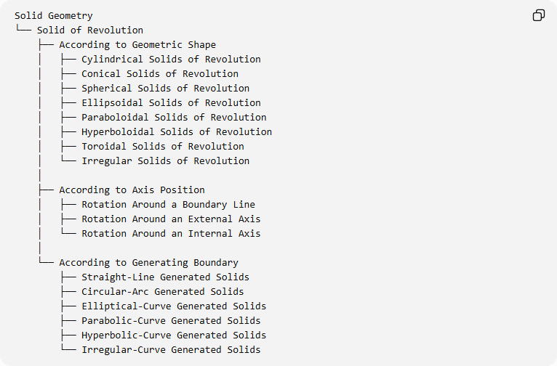
Solid Geometry
└── Solid of Revolution
├── According to Geometric Shape
│ ├── Cylindrical Solids of Revolution
│ ├── Conical Solids of Revolution
│ ├── Spherical Solids of Revolution
│ ├── Ellipsoidal Solids of Revolution
│ ├── Paraboloidal Solids of Revolution
│ ├── Hyperboloidal Solids of Revolution
│ ├── Toroidal Solids of Revolution
│ └── Irregular Solids of Revolution
│
├── According to Axis Position
│ ├── Rotation Around a Boundary Line
│ ├── Rotation Around an External Axis
│ └── Rotation Around an Internal Axis
│
└── According to Generating Boundary
├── Straight-Line Generated Solids
├── Circular-Arc Generated Solids
├── Elliptical-Curve Generated Solids
├── Parabolic-Curve Generated Solids
├── Hyperbolic-Curve Generated Solids
└── Irregular-Curve Generated Solids

Key Points
# Source: AI Source: Provided by: [Data Path: Persons Table -> ID Column: 1, Name_En Column: Motasem Essam] -> From: [ChatGPT] on [7/25/2026]
- A solid of revolution is generated by rotating a filled plane region around a fixed straight axis.
- A complete revolution corresponds to ${360}^{∘}$.
- The fixed rotation line is called the axis of revolution.
- The boundary generates the surface of revolution.
- The filled region generates the solid of revolution.
- Cross-sections perpendicular to the axis are circular disks or annuli.
- Different generating regions and axis positions produce different solids.
- Volume can be calculated using the disk, washer, shell, or Pappus methods.
- Surface area can be calculated using integration.

Conclusion
# Source: AI Source: Provided by: [Data Path: Persons Table -> ID Column: 1, Name_En Column: Motasem Essam] -> From: [ChatGPT] on [7/25/2026]
A Solid of Revolution is an important category of three-dimensional geometric solids generated through rotational movement. It includes many familiar solids, such as cylinders, cones, spheres, spheroids, paraboloids, hyperboloids, and tori. Its mathematical properties provide a foundation for understanding rotational geometry, volume calculation, surface generation, engineering design, and three-dimensional modeling.

Sources
# Source: AI Source: Provided by: [Data Path: Persons Table -> ID Column: 1, Name_En Column: Motasem Essam] -> From: [ChatGPT] on [7/25/2026]
- University of Alberta – Volumes of Solids of Revolution
- Aalto University – Differential and Integral Calculus
- Uttarakhand Open University – Integration and Volume and Surface of Solids of Revolution
- University of Lethbridge – Surface Area of a Solid of Revolution

